# Architecture requirements

## Integration requirements

The Integration channel section will cover all information in regards to the program interfacing with the multiple systems, what systems will be involved in the program and how this interfacing will be done. Integration channels refer to the endpoints that is created in the system and the interfaces and interface channels to realize this program. Integration with the multiple areas of the system will play a major part in the connection of the device, website and the database aspects.

### Integration channel

Integration will be facilitated between the website, mobile application and databases. The database will serve as the endpoint in most of the user cases and only be seen as a middle step in the retrieval of marks form the student and lecturer side. The hosted database will be a MySQL database (as per client specification) and will have interfacing to the ALDOP to retrieve student, tutor and lecturer information.

All applications will have internet requirements as with the mark, mark sheet and change logs will be uploaded via the internet to a local database that stores mark information. Mobile device, internet connection will be used in this regard to connect to the DNS of the local storage server. The website will be hosted in concert with the database and PHP can be used for server side data transfer.

Both the website and mobile application is required to do real time uploads to the database if internet connection can be made and will require a constant syncing of information. The information stored on the database will be accessible from both website and mobile application to view individual marks and final marks. This data will be used by the reporting tools to generate the grafts and statistical information. A failsafe must be included for the mobile application if internet connectivity is not available must the application continue until the end of the current mark sheet. This must allow that a butch upload of the marks must be done. The batch size must be no more that the size of the current mark sheet and has to be check against the timestamp that is included in the version of the database at that time.

Dynamic roles will be allocated from the data interface to the ALDOP system. The marking process can only be started for lecturers and tutors login users and viewing of marks will be available to students in a personal capacity, a student can only see his or her mark. A lecturer will only be able to view that marks in a group capacity.

### Protocols

The protocols include all integration tools that will be used in the development of the program.

* FTP
* SOAP
* HTTPS

### API

API (Application Programming Interface)

Android

MySQL

ALDOP

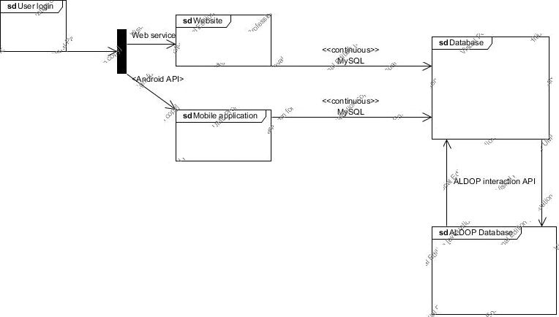

### Quality requirements

#### Performance

The interaction with the database must be able to host all students, tutors, teaching assistance within the IT faculty. This integration must be done so that there is no decrease in performance

#### Security

The interface must be secure and only interaction from a registered user via the mobile application or the website will be allowed as acceptable input. All interactions must be logged in a way that is accessible by staff but cannot be edited.

#### Usability

All registered personnel at the facility of IT must be able to use the website or application as long as the minimum requirements have been met.

The user must:

* Be a student, tutor, Teaching assistant or lecturer at the Faculty of Information technology
* Have an active internet connection
* Or a mobile device using android(Minimum API level to be confirmed)